VLSI Design Layout Code Documentation

Introduction
This document captures the experiment implementation details.

Code Details
File Description : This file contains all the code for implementation of the circuit canvas and the buttons.

Embed your circuit
Ctrl+Click(Mac:command+Click) on your circuit and copy a circuit data.
Then paste it into template below.
<!doctype html>
<html>
<head>
<meta http-equiv="Content-Type" content="text/html;charset=UTF-8" />
<script type="text/javascript" src="simcir.js"></script>
<link rel="stylesheet" type="text/css" href="simcir.css" />
<script type="text/javascript" src="simcir-basicset.js"></script> <link rel="stylesheet" type="text/css" href="simcir-basicset.css" /> <script type="text/javascript" src="simcir-library.js"></script> <title></title>
</head>
<body>
<div class="simcir"> <!-- paste here your circuit data --> </div>
</body>
</html>

Reuse your circuit
To reuse your circuit as library, use device 'In' and 'Out'.
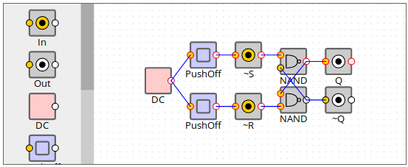

Then register it in JavaScript and add to the toolbox in HTML.
simcir.registerDevice('MyDevice', // paste here your circuit data );

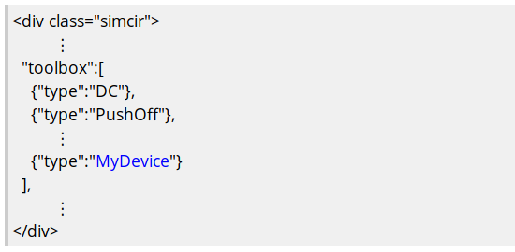

In this case, a new device 'RS-FF' is added. Try to Double-Click the 'RS-FF' :)
Remember that all the connectors on an input of 'In' and an output of 'Out' are disconnected internally when the device is reused.

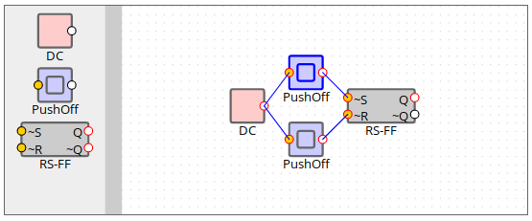

To customize the layout of library, add the "layout" property to your device with a text editor.
"rows" and "cols" define the size. nodes property contains 'label - position' pairs of nodes.
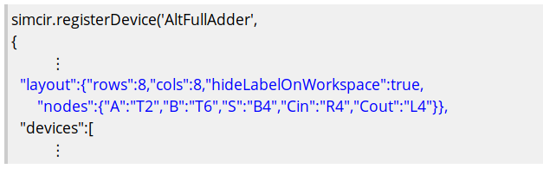
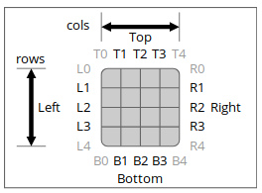

Customize a device
label, color, number of inputs, freq ...
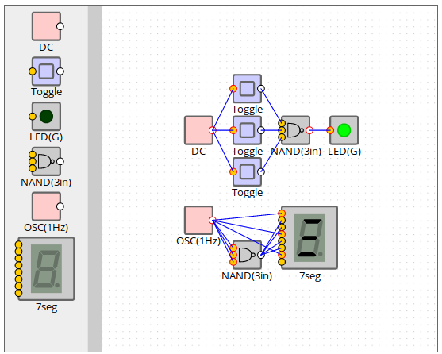

Components
